Experiment-12

Cursors

• Create a table with attributes students and marks.

• Insert values into the table.

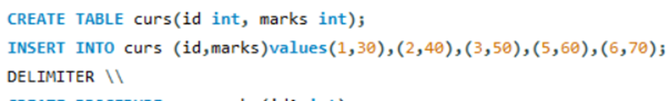

• Create a procedure, and fetch the marks of given id using a cursor.

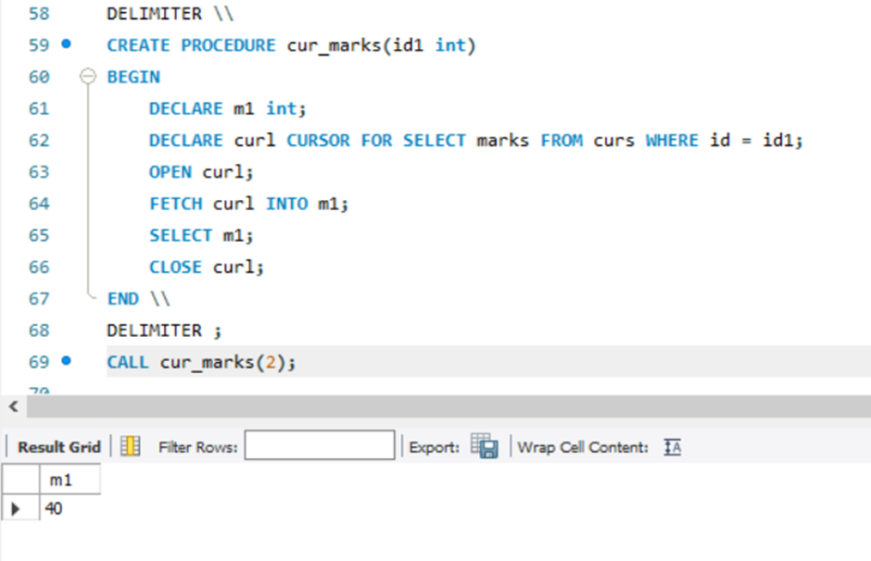

• Create a procedure, and fetch the highest marks using a cursor

